Skill System Design

Each skill will be comprised of:

1. **Basic Parameters**
   1. Name
   2. Description
   3. Mana Cost
   4. Cooldown Time
2. **Talent**

Modifier for skill that make them unique:

* 1. Damage: Point of damage inflicted
  2. Damage Type: Physical (reduced by player armor + evasion), Magical (reduced by player magic resistance), Pure, Heal
  3. Range Type: Single Target, Line Target, Near Self Area Target, Area Target
  4. Talent Type: Poison, Stun, Slow, Scale Physical, Scale Magical

1. **Rule**

Each skill can be a mixed of talents with certain rules:

1. Each Skill can only have one damage type
2. Each skill can only have one range type
3. Each skill can only have one attack type
4. Each skill can have multiple talent type

Each skill for now will also have certain rules regarding their leveling:

1. Skill level is from 1 – 5 max.
2. Each upgrade level will increase mana cost, damage by 20%. To illustrate:

|  |  |  |
| --- | --- | --- |
| Level | Point | Percentage (%) |
| 1 | 100 | 0 |
| 2 | 120 | 20 |
| 3 | 144 | 44 |
| 4 | 173 | 73 |
| 5 | 208 | 108 |

Technical Documentation

To build the skill editor tool, we will consider:

* User is design team with technical and non technical knowledge of Unity
* Will be using Unity Custom Editor to minimize friction when designing skill
* Skill will be saved as a ScriptableObject type Skill so that can be implemented next by the engineering team
* To allow user to test the skill result, a Skill Test Scene will be created
  + Scene will have hero character and enemies character put in triangle position
  + VFX for skill will use available template VFX available, later implementation or / changes will be implemented later by the team in charge
  + Enemies character will use default enemies as test dummy

|  |  |
| --- | --- |
| HP | 1000 |
| Armor | 50 |
| Evasion | 50 |
| Magic Resistance | 50 |

* + Hero character will use default hero stat

|  |  |
| --- | --- |
| Max HP | 5000 |
| HP | 2000 |
| Mana | 2000 |
| Phys Attack | 500 |
| Magic Attack | 500 |

* + Calculation for Physical Attack

Base Damage = (Phys Attack + Skill Damage)

Bonus Scale Strength = BaseDamage * (Scale Strength / 100 * Phys Attack)

Bonus Scale Magic = BaseDamage * (Scale Magic / 100 * Magic Attack)

AttackDamage = BaseDamage + Bonus Scale Strength + Bonus Scale Magic

Armor Reduction = Attack Damage * (Armor / 100 / 2);

EvadeReduction = Attack Damage * (Evasion / 100 / 2);

TotalDamage = Attack Damage – Armor Reduction – Evade Reduction

* + Calculation for Magic Attack

Base Damage = (Magic Attack + Skill Damage)

Bonus Scale Strength = BaseDamage * (Scale Strength / 100 * Phys Attack)

Bonus Scale Magic = BaseDamage * (Scale Magic / 100 * Magic Attack)

AttackDamage = BaseDamage + Bonus Scale Strength + Bonus Scale Magic

Magic Reduction = Attack Damage * (Magic Resistance / 100 / 2);

TotalDamage = Attack Damage – Magic Reduction

* + Calculation for Pure Attack

Base Damage = Skill Damage

Bonus Scale Strength = BaseDamage * (Scale Strength / 100 * Phys Attack)

Bonus Scale Magic = BaseDamage * (Scale Magic / 100 * Magic Attack)

Total Damage = Base Damge + Bonus Scale Strength + Bonus Scale Magic

* + Calculation for Heal

Base Damage = Skill Damage

Bonus Scale Strength = BaseDamage * (Scale Strength / 100 * Phys Attack)

Bonus Scale Magic = BaseDamage * (Scale Magic / 100 * Magic Attack)

Total Damage = -1 * Base Damge + Bonus Scale Strength + Bonus Scale Magic

* + Poison Damage

Poison per tick is based on the damage value set by user.

Poison will stay for 3 seconds

* + Stun / Slow

Status will stay for as long as the length value set by user

1. **Skill Editor Window**

Here is the design for skill editor window:

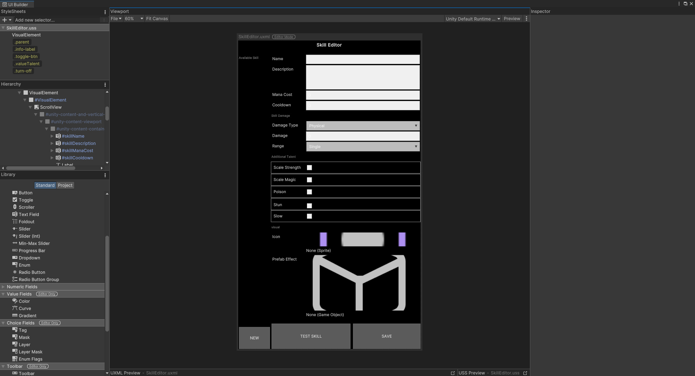

1. The left side is list for skill available / created. User can pick one from the list to edit the skill.
2. The right side is the skill parameter for input:

* Skill name
* Skill description
* Skill mana cost
* Skill cooldown
* Damage Type
* Damage
* Range Type
* Additional Talents:
  + Scale with strength, with value
  + Scale with magic, with value
  + Poison, with poison per tick
  + Stun, with stun length
  + Slow, with slow length
* Icon for skill
* Skill effect

1. Button Save to create or update the skill based on name. New skill will be saved as Scriptable Object based on name in Assets/Skills
2. Button Test Skill will change the scene to TestSkillScene and go into Play mode so that user can test the skill
3. Button New to empty all parameters
4. **Test Skill Scene**

To be able to test the skill on monster / creep user must open the TestSkillScene.scene and press on Play Mode.

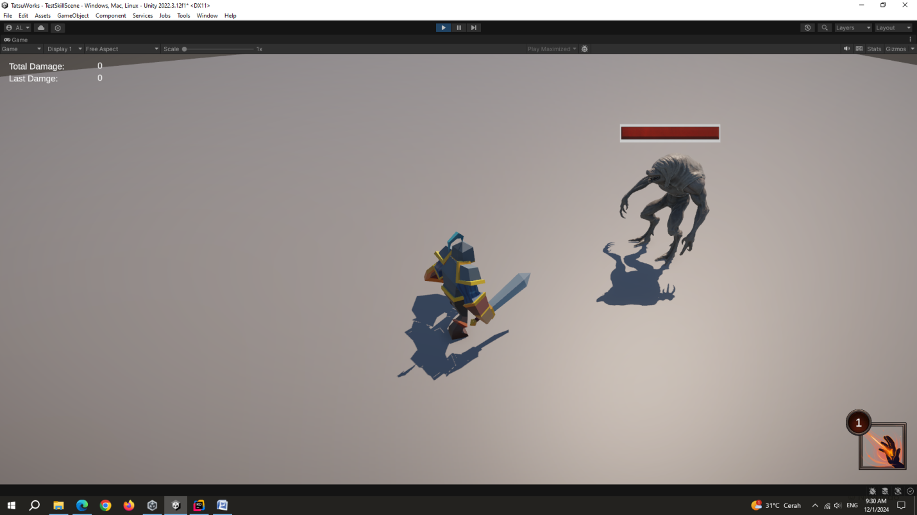

Scene contains:

* + - * Hero character
      * Creep character, include status effect: stun, slow, poison
      * Skill button, on bottom right is a button to cast skill. If skill is on cooldown, there will be a message in the log
      * Upgrade button on top left of Skill button to upgrade the ability level
      * On top left are some stats: total damage this session and last damage point

1. **Manual**

To use the skill editor, this is the recommended steps for user

1. Open TestSkillScene, you can find it in Assets/Scenes folder
2. Start Play mode by pressing play button on middle top

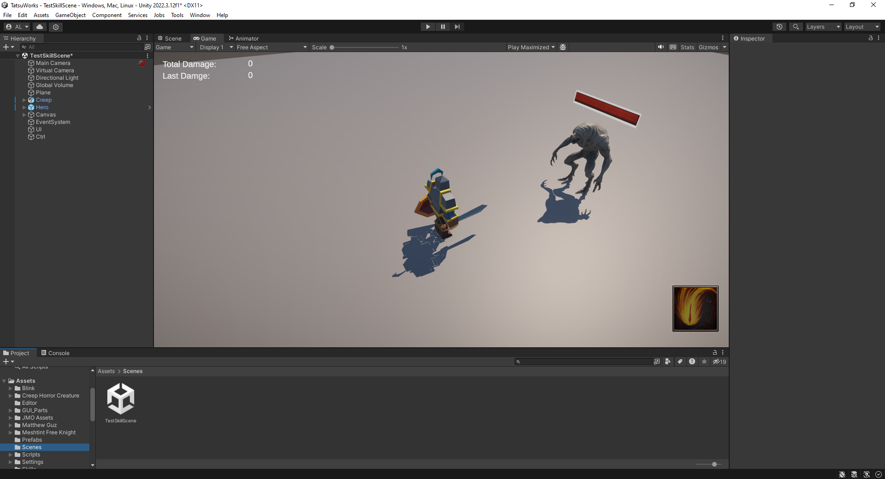

1. Open Skill Editor from menu bar: tools / Skill Creation Editor

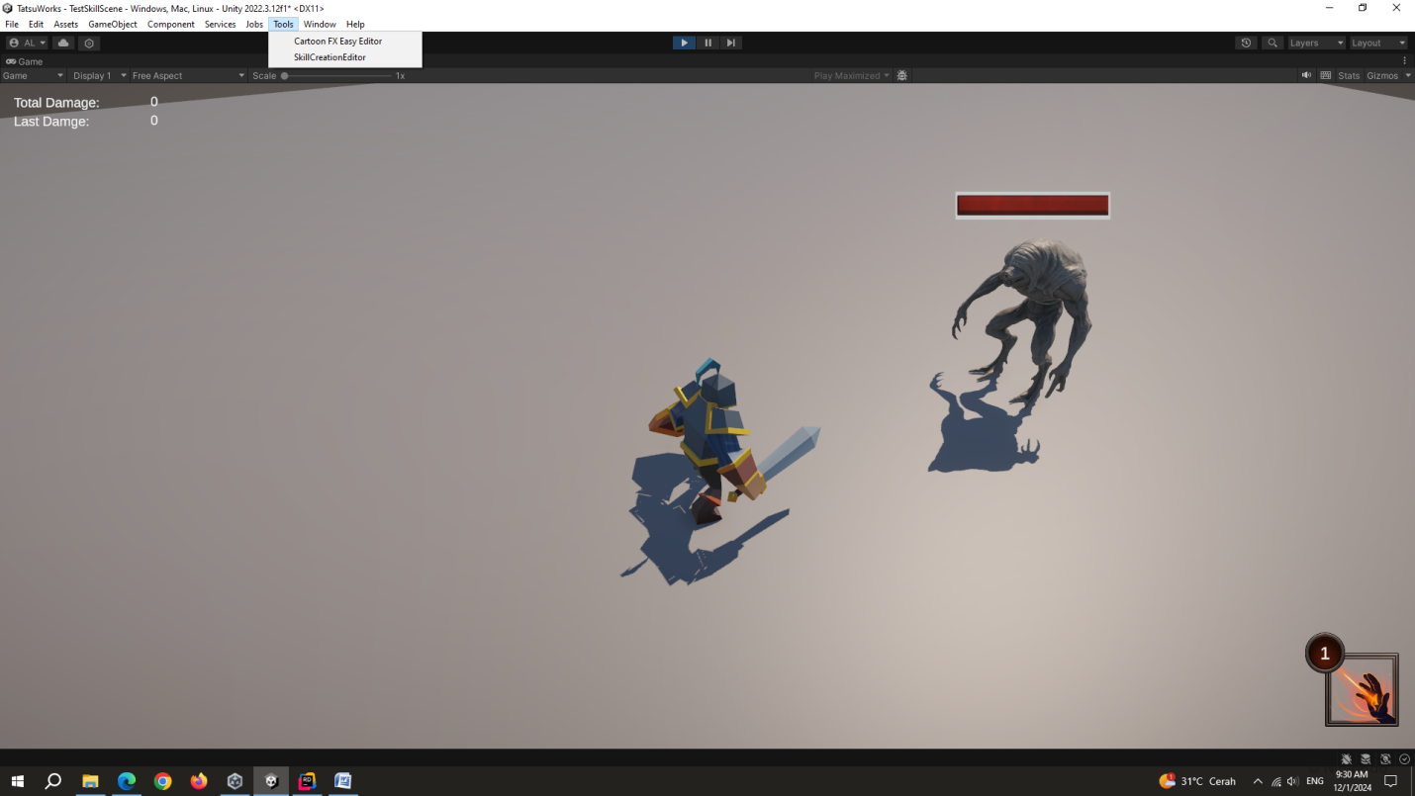

1. Now you can pick the skill from left list or create new skill by inputting the parameters

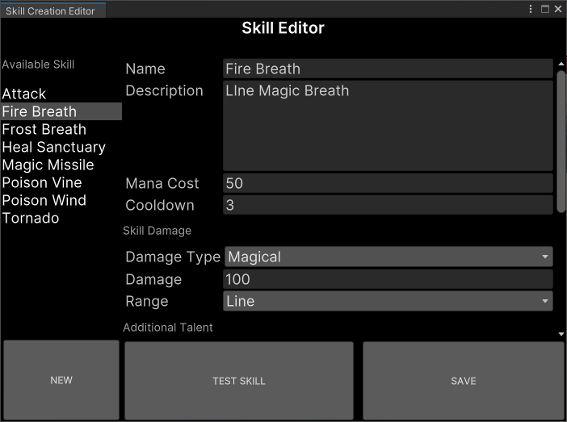

1. To Test the skill you pick, click on Test Skill and the ability will be set to the game at bottom right. Click it to cast it

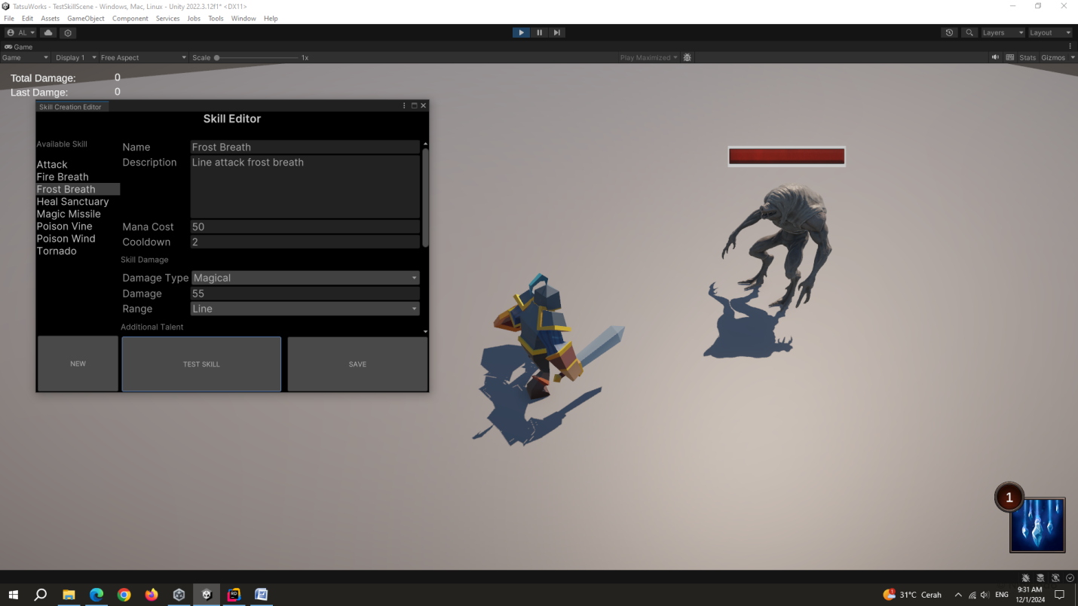

1. You can modify any skill and press save to test the changes
2. Click on the ability to cast the skill

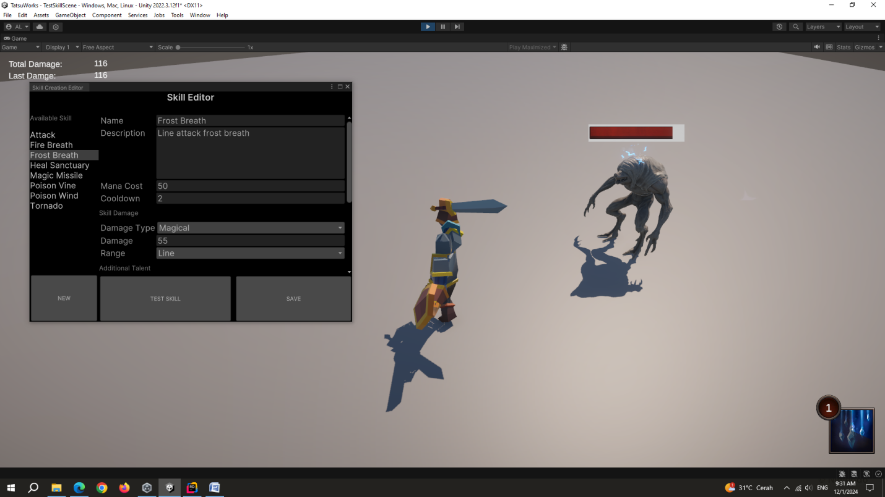

1. Upgrade the ability by clicking on the number button

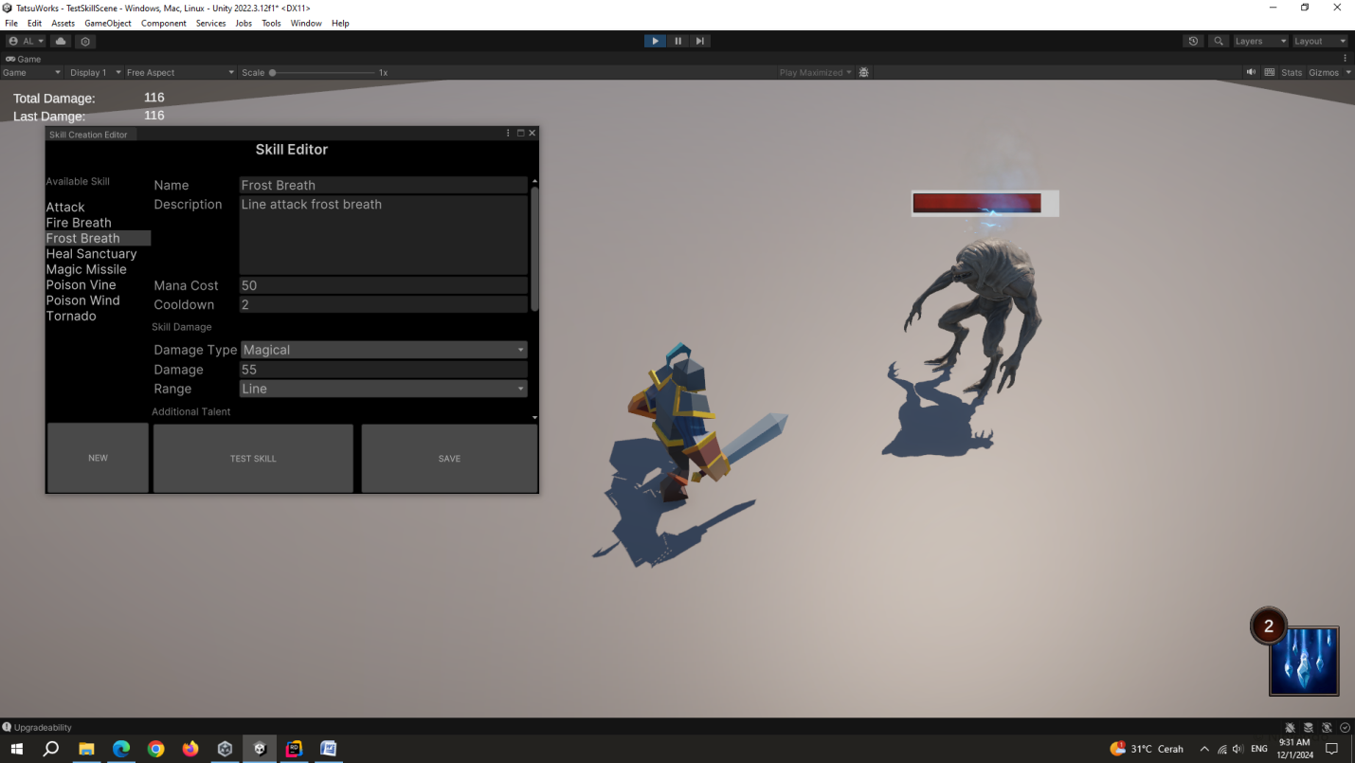

Available skills as example to test are in Assets/Skills:

* + - * Fire Ball (single fire ball projectile)
      * Poison Wind (line attack poison wind + slow)
      * Tornado (area damage + stun)
      * Heal Sanctuary (near area + heal)